**Light Spectrum**

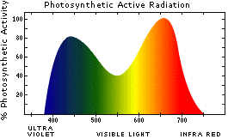

**Maximum Photosynthetic Activity**

**400-500 and 600-700**

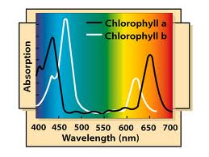

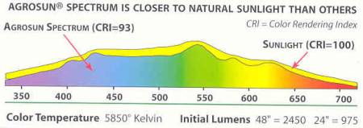

**Agrosun Full Spectrum Fluorescent Grow Light**

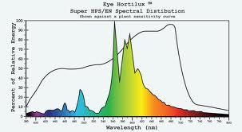

**T5 Fluorescent**

**Light Spectrum**

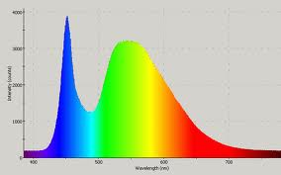

**Cool White Fluorescent**

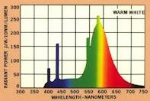

**Warm White Fluorescent**

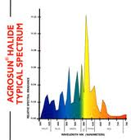

**Halide**

